# **Highs and Lows**

**Zoe's avatar**

[Zoe](https://substack.com/@zoeffc)

Dec 20, 2024

Share

Hello there!

This is my last post of 2024. Guess what? I am one of those people who gets super contemplative around the new year (and my birthday). For that reason, it feels valuable to me to look back at the year and consider the highs and lows. I would love to share a Highs-and-Lows Round-Up with you all today.

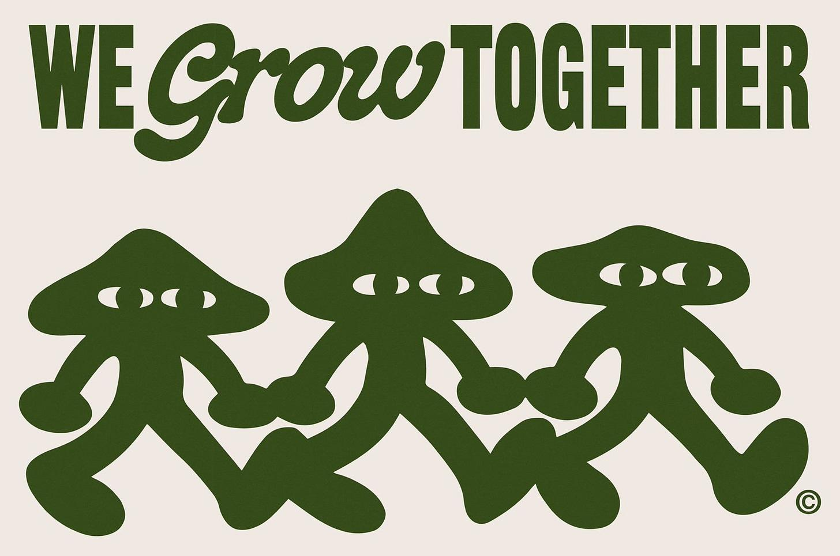

artist unknown

**High**: I started the Femme Futures Cooperative over six months ago. This brainchild has given me a space to reflect on my experiences as an early-career professional and connect with other people who either *are* going through the same thing or *have* gone through it. It makes my day when one of you tells me that a newsletter struck a chord with you.

**Low:** I have spent the year struggling with some pretty severe burnout. Frankly, I feel like I am too young to burnout and I probably have no idea what I am talking about. Nonetheless, I check a lot of the symptoms boxes and have been watching myself actively strive towards recovery. I will talk a lot more about this in the months to come — it is not a tunnel that I have made my way through just yet.

**High**: I finally feel like I’ve hit my stride when it comes to making friends and building community as an adult. If you know me in real life, you know that it takes me a minute to warm up to people. As much as I wish it were otherwise, I will simply never be the life of the party. However, I have always had a talent for having some of the coolest and best people as close friends. Learning how to make friends as an adult out of school has been tricky. Want to know the secret? There is no secret; it’s just a matter of patience.

**Low:** I got hands-on experience navigating challenging personalities in high-stress situations. Again.

**High:** I joined a team that feels aligned with my values and work style and am doing work that feels like it is growing me in a way that I want to grow! We had our team year end celebration today and I walked away feeling accepted and valued. I feel extremely lucky to be in this situation right now.

**Low:** I moved away from the direct-impact activism that I had been doing and am taking some time to hone in on skills that make me better suited to doing real long-term good. When I graduated from college, I immediately went into climate activism as a profession. Making the world a better place is why I get out of bed each morning. However, even heroes face burnout. These ended up being unsustainable environments for me in the long term — however, without those, I don’t know if I’d be here, writing Femme Futures. It is a slightly more DIY approach to making my world a better place.

**High:** I am taking my experiences and using them to make the world a place that feels more open and accepting of people like me. It makes me feel like the challenges that I have faced so far on my professional journey were not for nothing if they can make anyone feel less alone in their feelings.

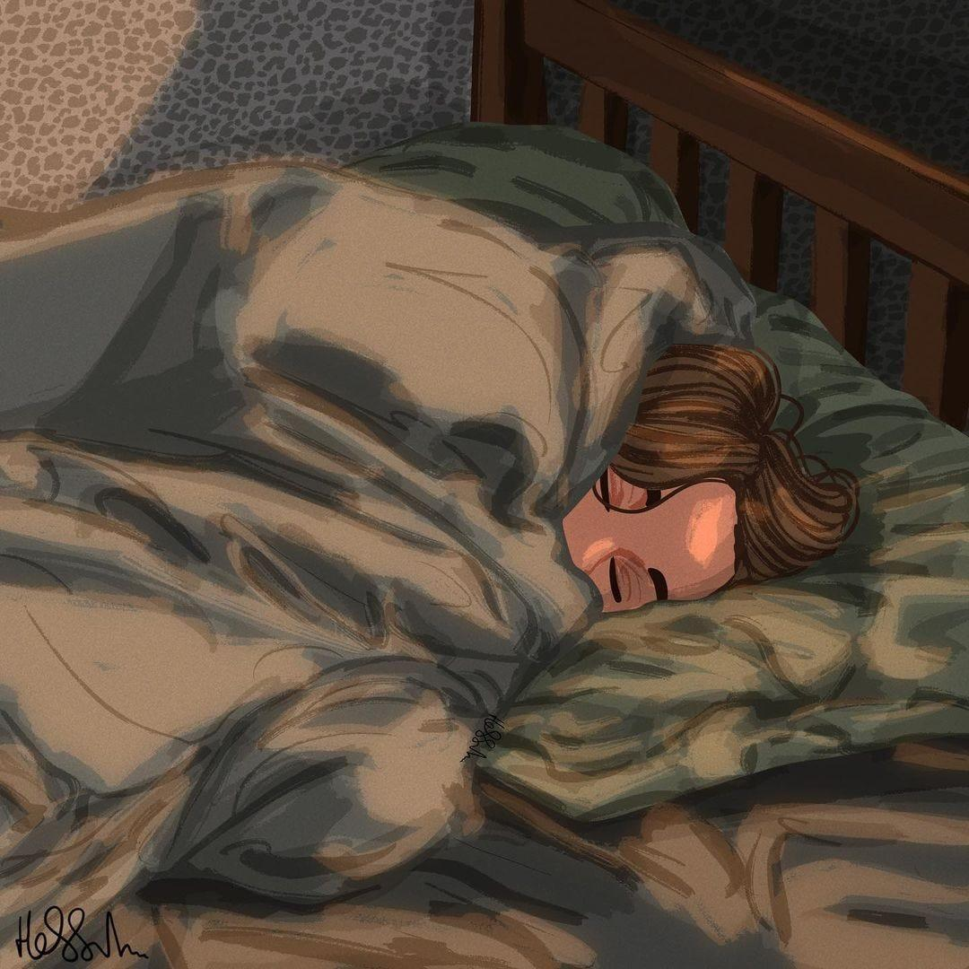

@hessah._.art on instagram

I have ended the last several years grateful to be done with that particular chapter. Perhaps that is a side-effect of being in your twenties, or maybe I am just depressed. Whatever the case may be, I am happier this year to accept that feeling. There were some things that happened this year that I would pay dearly to never experience again. There were also some incredible things that happened this year. I am not asking for 2025 to be only good — there are simply too many days that can go either way — but I am asking myself to notice the good with the bad and respect the balance that it has in my life.

With that, I want to wish you all a happy new year!

Love,

Zoe